Mr Victor (President of FMM) and Mr Jules (Director of Akama) visited in Taolagnaro
24 – 27 April 2006.

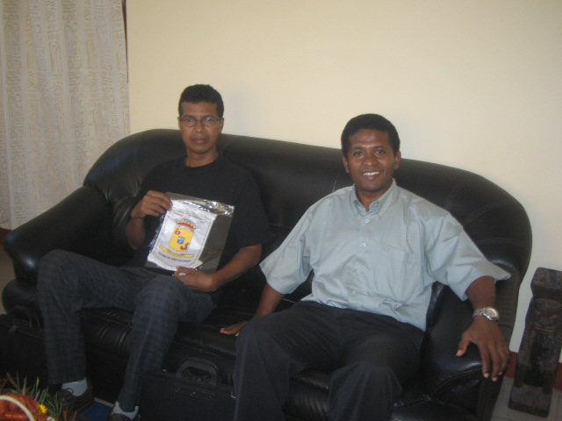

Victor meet and give information about Human Right for Deaf and FMM to the Mayor of Taolagnaro. Mayor is surprised when he saw Sign Language with Interpret. He is ready to help and prepare the Deaf in Taolagnaro. Mayor give the Flag logo of Taolagnaro for FMM

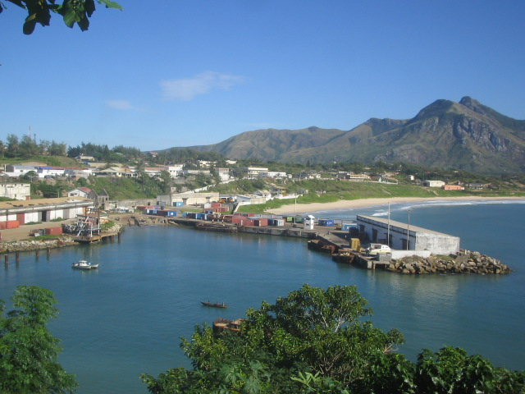

This the city of Taolagnaro. Victor and Jules visit to the Director of Education, Region, etc…
They don’t know about the Deaf in Taolagnaro. FMM give the money 100.000 Ariary to Director of Education because collect the Deaf Childrens,… In Taolagnaro weather is calm every year (not cold, sometime raining,….). Expensive the live exp: 3 plus from at Antananarivo. It is different life.

